# Brainstorm

## Before you collaborate

#### A little bit of preparation goes a long way with this session. Here’s what you need to do to get going.

##### 10 minutes

**1**

## Define your problem statement

#### What problem are you trying to solve? Frame your problem as a How Might We statement. This will be the focus of your brainstorm.

##### 5 minutes

**2**

## Brainstorm

#### Write down any ideas that come to mind that address your problem statement.

##### 10 minutes

**3**

## Group ideas

#### Take turns sharing your ideas while clustering similar or related notes as you go. Once all sticky notes have been grouped, give each cluster a sentence-like label. If a cluster is bigger than six sticky notes, try and see if you and break it up into smaller sub-groups.

##### 20 minutes

**4**

## Prioritize

#### Your team should all be on the same page about what's important moving forward. Place your ideas on this grid to determine which ideas are important and which are feasible.

##### 20 minutes

## After you collaborate

You can export the mural as an image or pdf to share with members of your company who might find it helpful.

**Quick add-ons**

The device can be made more portable by using small lipo batter

# & idea prioritization

1. Team gathering

###### SUMITHA M

###### PREMALATHA K

###### ABITHA G

###### SARANYA S

**TIP**

Add customizable tags to sticky notes to make it easier to find, browse, organize, and categorize important ideas as themes within your mural.

Define who should participate in the session and send an

An alarm button

**PROBLEM**

**A NOVAL FOR REAL-TIME COMMUNICATION SYSTEM POWRED BY AI FOR SPECIALLY ABLED**

The system

The system can

The battery must

A notification

Design the

Research

**A Share the mural**

invite. Share relevant information or pre-work ahead.

Modifying

translation can be set up for

Video of hand must be able be operated by

The user should

last longer and

The device

to remind

application with should based

**Share a view link** to the mural with stakeholders to keep

goals based

should be

any emergency

gestures

to recognize

voice

feel like a normal can work even

must be small

them about

inclusitivity to

on data

Use this template in your own brainstorming sessions so your team can unleash their imagination and start shaping concepts even if you're not sitting in the same room.

1. Set the goal

Think about the problem you'll be focusing on solving in the brainstorming session.

1. Learn how to use the facilitation tools

Use the Facilitation Superpowers to run a happy and productive session.

on circumstance

faultless

uses for the specially abled person

converted into speech

braille language

commands and buttons

person by using this device

with an emergency backup

and are easily portable

their daily tasks

all types of people

centric perspective

them in the loop about the outcomes of the session.

B Export the mural

Export a copy of the mural as a PNG or PDF to attach to emails, include in slides, or save in your drive.

**10 minutes** to prepare

**1 hour** to collaborate

**2-8 people** recommended

[Open article](https://support.mural.co/en/articles/2113740-facilitation-superpowers)

Cheeks muscle movement can be used to word they are trying to speak

### Key rules of brainstorming

The machine is made to learn all the actions so that it easily detects the movement of the person

To run an smooth and productive session

### Keep moving forward

Strategy blueprint

Define the components of a new idea or strategy.

[Open the template](https://app.mural.co/template/e95f612a-f72a-4772-bc48-545aaa04e0c9/984865a6-0a96-4472-a48d-47639307b3ca)

**Customer experience journey map**

Understand customer needs, motivations, and

Stay in topic. Defer judgment.

Encourage wild ideas. Listen to others.

### Importance

High-quality audio and video Messaging and chat

Screen Sharing Meeting transcription

Noise suppression and muting Language translation within meeting

LAN/Internet AADI display system

Data Applications Custom Display Programs

Instruments/sensors on serlal cable

Instruments/Sensor on CCP/IP

If each of these

obstacles for an experience.

[Open the template](https://app.mural.co/template/b7114010-3a67-4d63-a51d-6f2cedc9633f/c1b465ab-57af-4624-8faf-ebb312edc0eb)

Placing a sensor that detects hand sign and gets inputs through camera which is then converted into speech

Go for volume. If possible, be visual.

tasks could get

done without any difficulty or cost, which would have the most positive impact?

RTC

Real-time computing Protocols are dependent Data transfers

Two Types

Hard real time Soft real time

Real time communication Web server HTML/CSS

Web browser Browser

function

Strengths, weaknesses, opportunities & threats

Identify strengths, weaknesses, opportunities, and threats (SWOT) to develop a plan.

The software can work both online and offline

[Open the template](https://app.mural.co/template/6a062671-89ee-4b76-9409-2603d8b098be/ca270343-1d54-4952-9d8c-fbc303ffd0f2)

**TIP**

Participants can use their cursors to point at where sticky notes should go on the grid. The facilitator can confirm the spot by using the laser pointer holding the **H key** on the keyboard.

[**Share template feedback**](https://muralco.typeform.com/to/CiqaHVat?typeform-source=app.mural.co)

[**Share template feedback**](https://muralco.typeform.com/to/CiqaHVat?typeform-source=app.mural.co)

### Feasibility

Regardless of their importance, which tasks are more feasible than others? (Cost, time, effort, complexity, etc.)

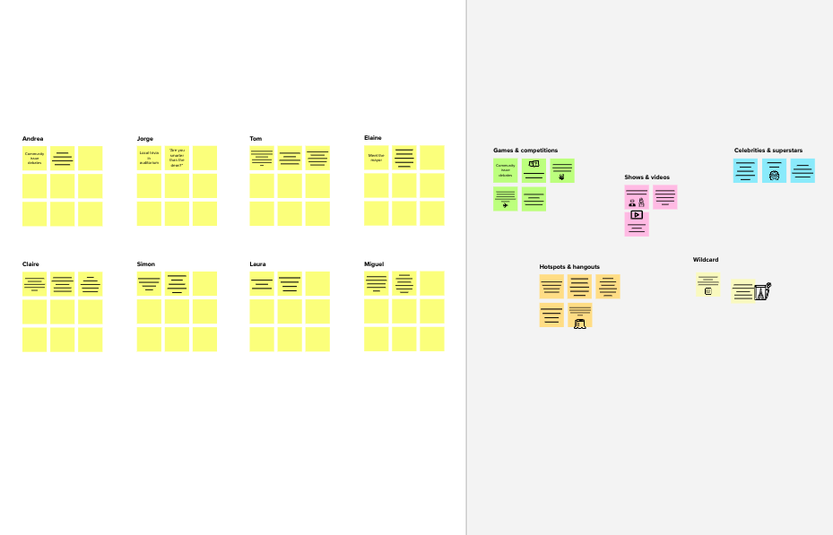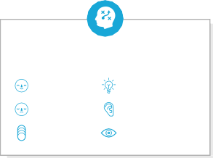

**Template**

**Need some inspiration?**

See a finished version of this template to kickstart your work.

[**Open example**](https://app.mural.co/template/e5a93b7b-49f2-48c9-afd7-a635d860eba6/93f1b98d-b2d2-4695-8e85-7e9c0d2fd9b9)

|  |  |  |  |  |
| --- | --- | --- | --- | --- |
|  |  |  |  |  |
|  |  |  |  |  |